**PC & Cell Remote Support Setup**

**Go to the internet browser of your choice (Chrome, Microsoft Edge, etc...)**

**Type help.pcncell.net in the internet’s search bar and press “Enter” or Search.**

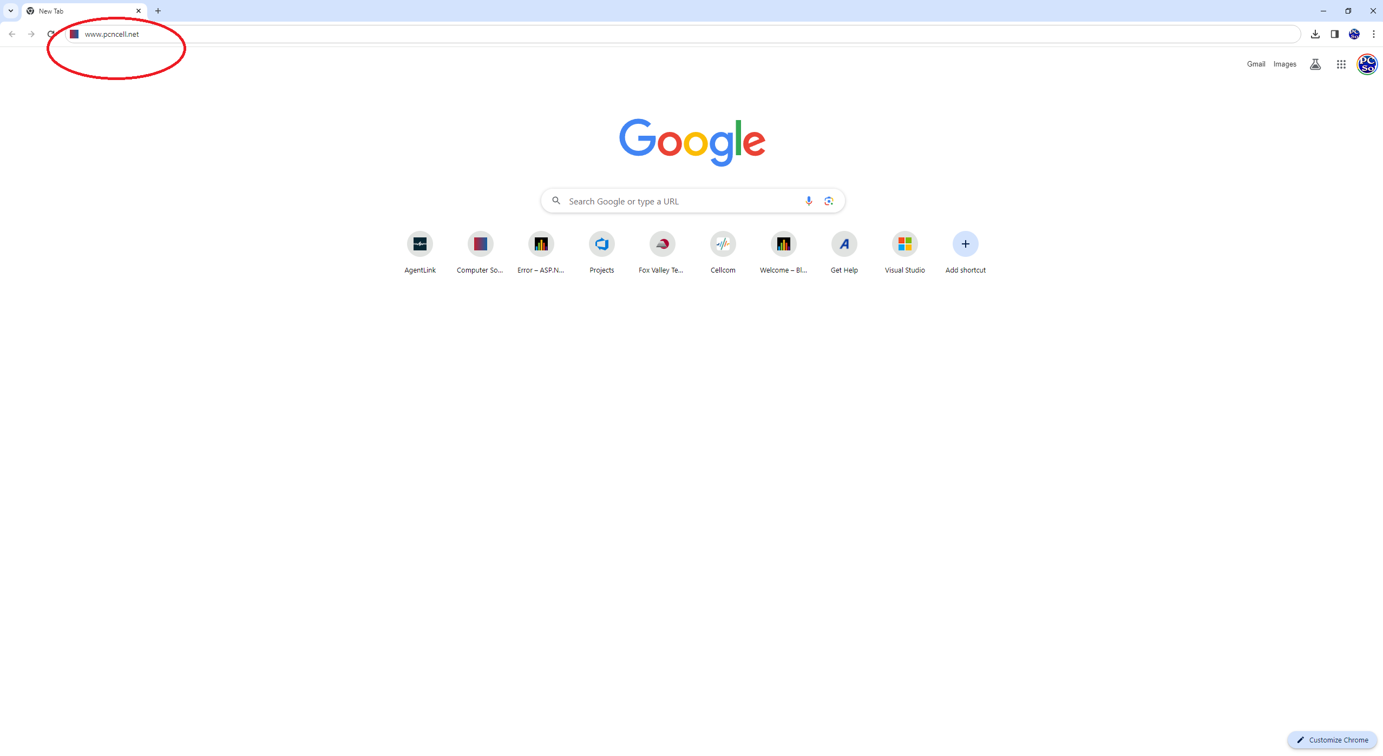

**(A message may appear saying, "Do you wish to trust this download. Click "Trust", "Keep" or "Run Anyway".)**

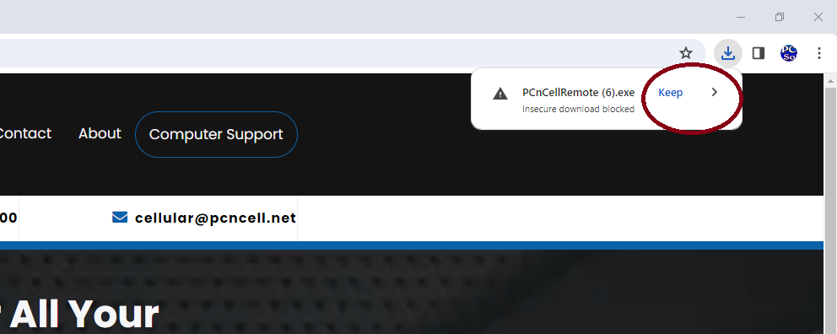

**In your “Downloads” folder you’ll see the red “PCnCellRemote” button click it, if you haven’t already opened it.**

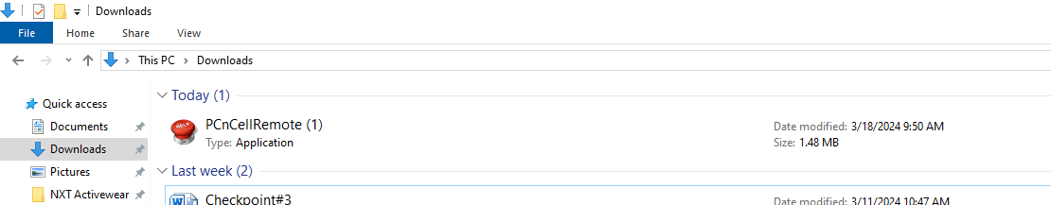

**A download will begin after searching for help.pcncell.net.**

**And then a "PC & Cell Remote Support" popup with a giant red Help Button will appear.**

**On this Popup click on the name, "Keith" or “HelpTWO”.**

**Once clicked, give us a call and we can remote into your computer and help you solve whatever issues your having.**

